Instructions for Using Rowsfir Products

1. Install MobiFlightConnector .
2. 2.Install FSUIPC7.

3.Open MobiFlightConnector and load the mcc configuration file. (It is necessary to correctly select the product model and the corresponding configuration file for the aircraft model.)

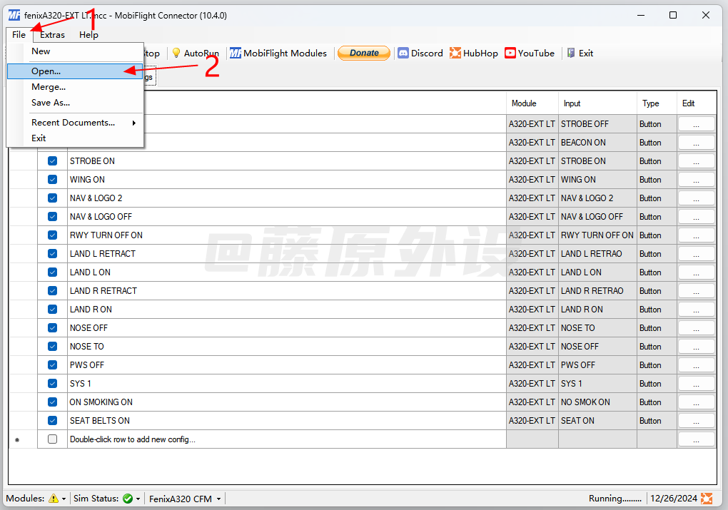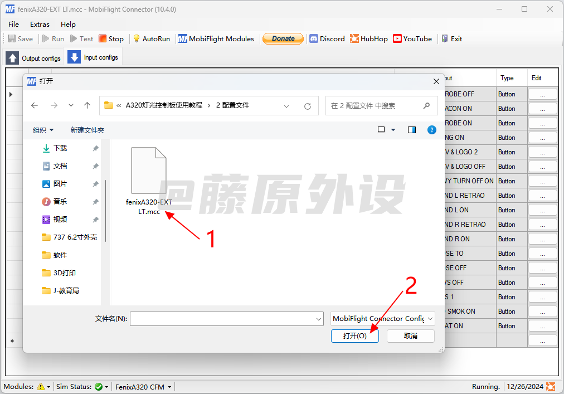

1. Load Hardware Device (Only Needs to Be Done Once)

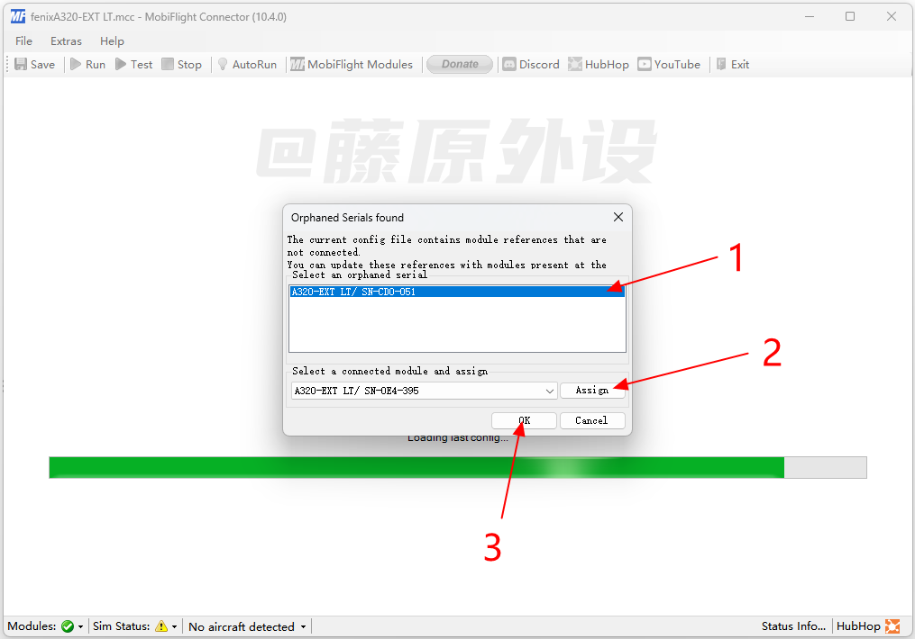

5.After launching Microsoft Flight Simulator 2020, FSUIPC7 will run automatically. Select the FENIX A320 aircraft model, enter the game, click RNU to load the hardware, and then you can use the lighting peripherals in the game. (After normally installing and starting all software, hardware, and the game, the lower right corner will show a green √ status. If a yellow exclamation mark appears, please check whether the software is installed correctly.)

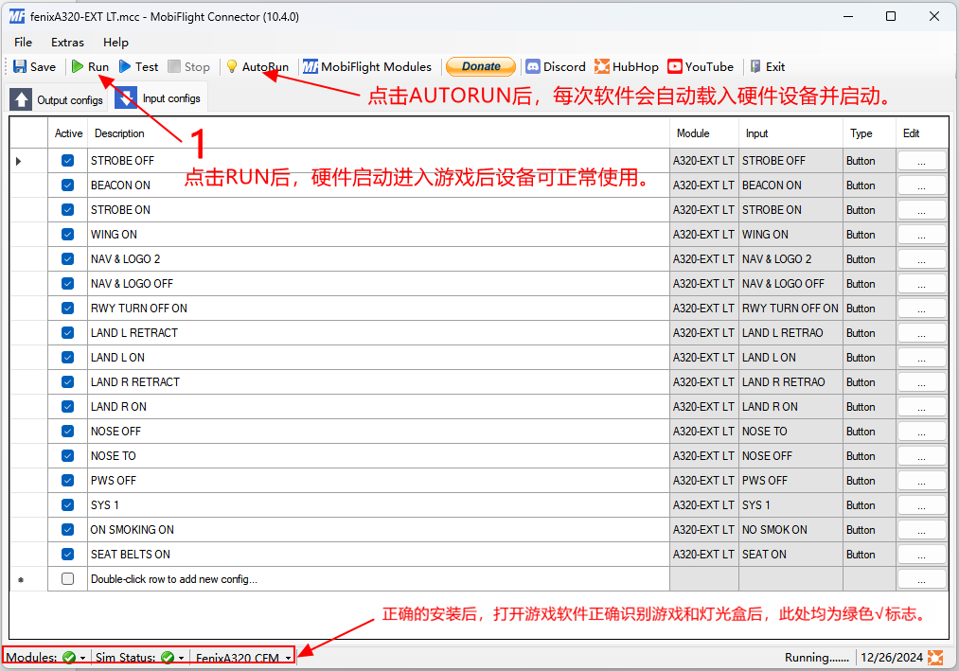

6.MobiFlightConnectors is a button-binding software between peripherals and games, featuring powerful functions for defining buttons of gaming peripherals. You can check the software's help page or watch the tutorial videos on the official website. You can also take the initiative to make hardware peripherals support more different aircraft models for gameplay. If you need any help, feel free to contact us. Have a great time!

Special Instructions:（A102 A106 A107）

Short Press (Quick Press): Lock the two buttons circled in red.

Long Press (Hold for 1 Second): Release the two buttons circled in red.

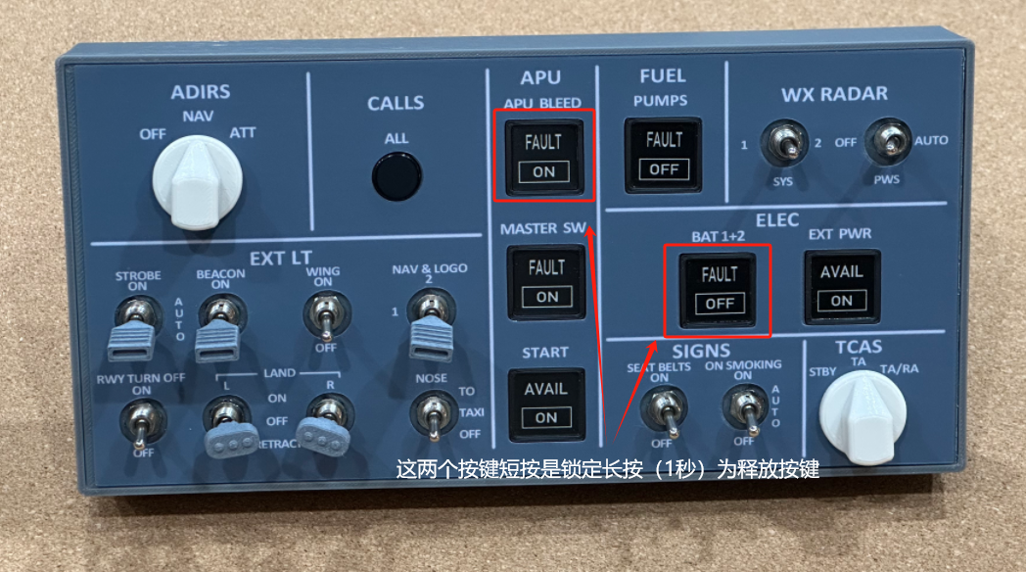

Common Questions and Solutions

1. The device shows no response when plugged into the computer, or the device cannot be properly recognized by the computer.  
   Solution: Connect the device to the USB port on the motherboard at the back of the host to ensure sufficient power supply for the device.
2. Or install CH340 driver.

Download link https://www.wch.cn/download/file?id=65

3.After installing all software, the device fails to interact with the game when entering the game. (A yellow exclamation mark appears in MF)  
Solution:  
Copy the \MSFS2020-module\mobiflight-event-module folder in the MobiFlightConnectorz installation directory to your Community folder \Community.